

Project Report

Preparation and Maintanence of ZOHO Books for Keerthi Sweets

# Introduction

This project report will describe the steps involved in preparing and maintaining Zoho Books for Keerthi Sweets. The report will also discuss the beneﬁts of using Zoho Books and how it can help Fresh Bites to improve its accounting processes and grow its business.

The scope of this project includes,

* Setting up the Zoho Books account and conﬁguring the preferences.
* 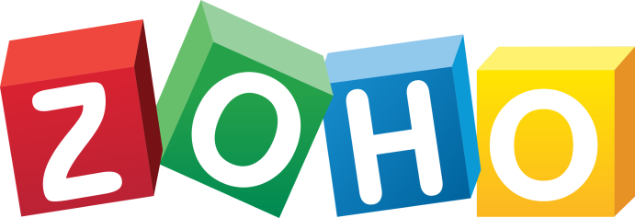Creating the necessary charts of accounts and other ﬁnancial statements.

**2**



# Problem Deﬁnition & Design Thinking

Empathy map,

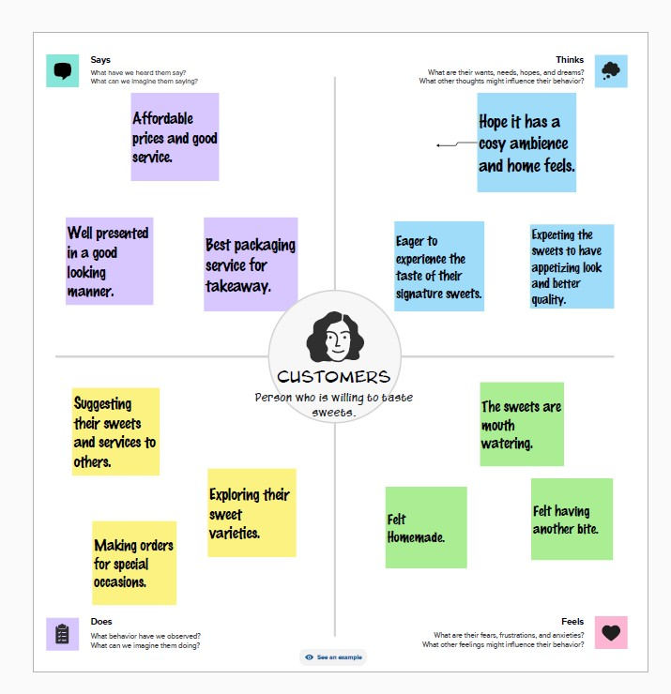

**3**



Brainstorming map,

# Result

# C:\Users\Hp\Pictures\Screenshots\Screenshot 2023-10-15 190132.png

**4**

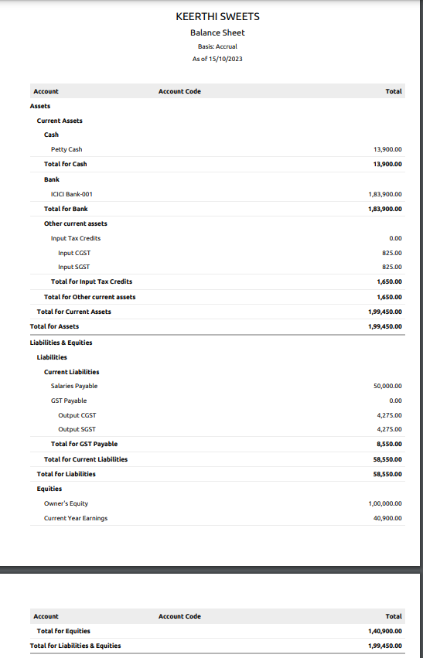

**5**



# ADVANTAGES & DISADVANTAGES

**Advantages of using Zoho Books for accounting:**

**Ease of use:** Zoho Books is a very user-friendly accounting software, even for those with no prior accounting experience. It has a simple and intuitive interface, and it offers a variety of tutorials and help resources.

**Affordability**: Zoho Books is very affordable, especially when compared to other popular accounting software programs. It offers a free plan for businesses with up to two users, and its paid plans start at just $15 per month.

**Comprehensive features:** Zoho Books offers a wide range of features, including

invoicing, billing, expense tracking, payroll, and reporting. It also offers a variety of

integrations with other business software programs, such as CRM and e-commerce platforms.

**Cloud-based:** Zoho Books is a cloud-based accounting software, which means that you can access it from anywhere with an internet connection. This makes it a good option

for businesses with remote employees or multiple locations.

**Disadvantages of using Zoho Books for accounting:**

**Limited user accounts:** The free plan for Zoho Books only allows for two users. If you need more user accounts, you will need to upgrade to a paid plan.

**Limited payroll features:** Zoho Books' payroll features are not as comprehensive as those of some other accounting software programs. For example, it does not offer support for direct deposit or payroll taxes.

**Customer support:** Zoho Books' customer support has been criticized by some users for being slow and unresponsive.

Overall, Zoho Books is a good accounting software program for small businesses and

freelancers. It is easy to use, affordable, and offers a wide range of features. However, it is important to be aware of the limitations of the free plan and the customer support

issues before you decide to use Zoho Books.

**6**



# APPLICATIONS

Zoho Books can be applied in a variety of businesses, including:

**Small businesses**: Zoho Books is a good option for small businesses because it is affordable and easy to use. It also offers a wide range of features, including invoicing, billing, expense tracking, payroll, and reporting.

**Freelancers**: Zoho Books is also a good option for freelancers because it offers a free plan for businesses with up to two users. This makes it a good choice for freelancers who are just starting out or who have a limited budget.

**E-commerce businesses**: Zoho Books integrates with a variety of e-commerce platforms, such as Shopify and WooCommerce. This makes it a good option for e-commerce businesses that need to track their sales and expenses.

**Service-based businesses**: Zoho Books is also a good option for service-based businesses, such as consulting ﬁrms and marketing agencies. It offers features such as time tracking and project management, which can be helpful for service-based businesses.

Overall, Zoho Books is a versatile accounting software program that can be applied in a variety of businesses. It is a good option for small businesses, freelancers, e-commerce businesses, and service-based businesses.

# CONCLUSION

We were able to use Zoho Books to effectively track the company's income and expenses, and to generate reports that helped the company to make informed ﬁnancial decisions.

Speciﬁcally, we used Zoho Books to:

* Set up the company's accounts and preferences
* Track all of the company's income and expenses

